**Name ____________________________ Period ___________ Date ________**

**Using Graphs**

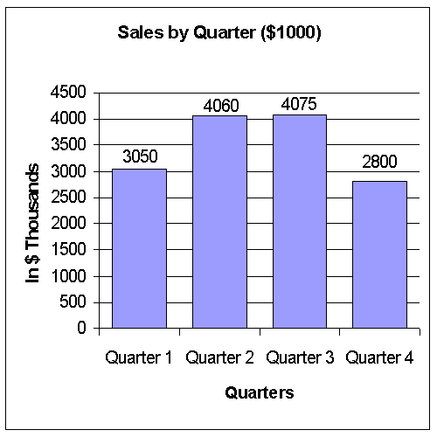

1. Which was the second best quarter?
2. What was the lowest quarterly sales?
3. In what quarter did we have the worst sales?
4. Did our sales for the year reach our budgeted goal of $14 million?
5. In what months did we have our best sales?

Use the graph to answer the next five questions.



1. What percent of my budget is spent on clothes?
2. If my monthly income is $600, how much do I spend on food?
3. What two expenditures, added together, equal what is spent on rent?
4. If I go to the movies on the last Tuesday of each month, under what heading would this expense be placed?
5. What is my single, largest expense?

Use this graph to answer the next five questions:

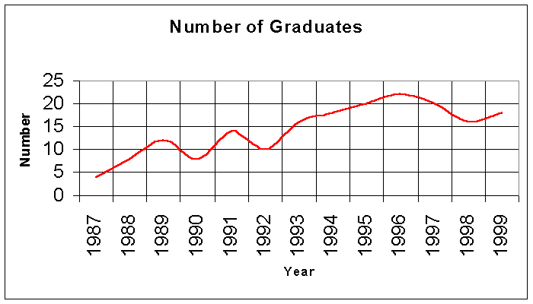

1. How many students graduated in 1992?
2. In what year did we have the greatest number of graduates?
3. What is the fewest number of graduates we have had?
4. Were there more graduates in 1989 or in 1998?
5. Taking the whole graph as a basis, will we likely have more or less graduates in 2000 than we had in 1999?

Use this graph to answer the next five questions:

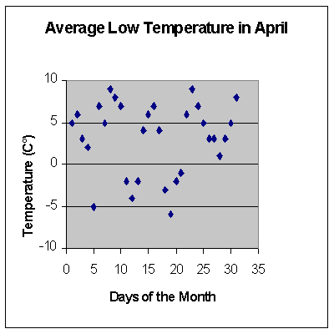

1. What was the lowest temperature for the month?
2. On what day(s) did we have the highest temperature recorded?
3. Estimate the average temperature for the month.
4. On how many days was the recorded temperature between 3 and 7°C?
5. What was the recorded temperature on April 26th?