Name_______________________

**Protein Synthesis Part 1**

**Using your knowledge of the basic process of protein synthesis;**

**1) Label parts/items 1-12**

**2) Use the DNA given (use right side) to construct RNA by filling in each blank.**

**3) Fully transcribe and translate the code into a protein drawing all tRNA**

**molecules and labeling all amino acids.**

**4) Be sure to finish drawing and filling in the appropriate parts until your protein is built.**

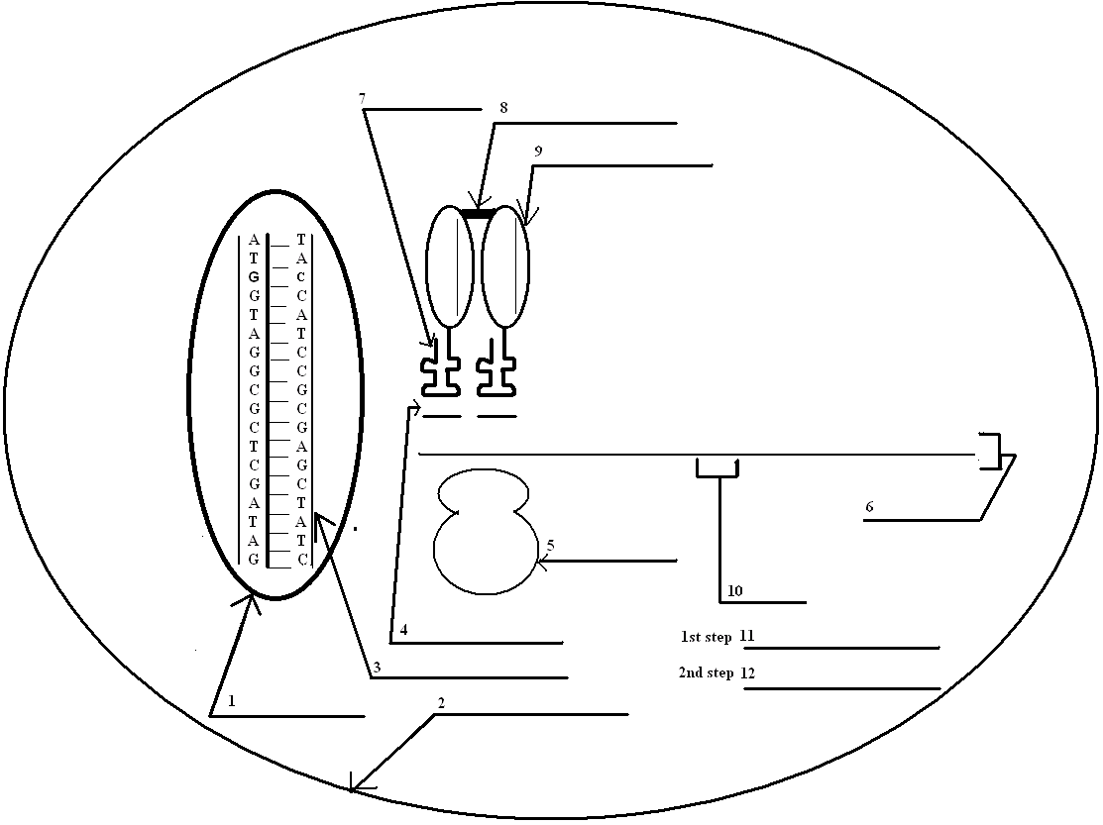

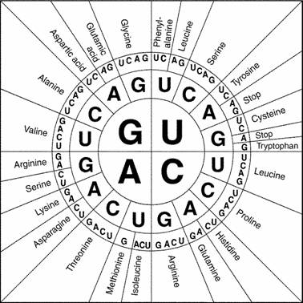

**Protein Synthesis Part 2**

**To ensure mastery, let us start with the first 5 amino acids that make up the human hemoglobin protein and have you work backwards to find the DNA!**

**\*Note: DNA code is said to be “degenerate” because different DNA codes can produce the same amino acids. In other words, some amino acids can be found using multiple codons. You have been given the last letter of the codon underneath each amino acid below. For example, an amino acid that has the following symbol (^U) underneath of it indicates that the last letter in the codon that coded for that amino acid is “U”.**

**Your protein: Valine – Leucine -- Proline – Alanine -**

**^C ^U ^A ^G**

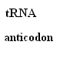 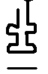   

**mRNA _______,_______,________,________**

**(codon)**

**_______________________________**

**DNA strand**

**(code inside _______________________________  
the lines!)**

**Please answer the questions below by circling the answer that makes the statement correct.**

1. mRNA is synthesized in **translation / transcription**.  
2. mRNA has a(n) **codon / anticodon**.  
3. **One / Three** codon(s) is (are) needed to code for one amino acid.  
4. tRNA brings amino acids to the **nucleus / ribosome**.

5. A polypeptide chain is a sequence of **amino acids / proteins**.

6. tRNA has **codons / anticodons**.

7. tRNA transfers amino acids during **transcription / translation**.

8. Ribosomes are the place where **transcription / translation** takes place.

9. Hemoglobin is used to **break down** **sugar / transport oxygen** in your body.

10. The alpha chain of human hemoglobin is 141 amino acids long. Those amino acids require **141 / 423** DNA

nucleotides.