Organic Molecules of Life Name _______________________________________________
Date ___________________________ Period _______________

Proteins

Organic Molecules of Life Name _______________________________________________
Date ___________________________ Period _______________

Carbohydrates

Organic Molecules of Life Name _______________________________________________
Date ___________________________ Period _______________

Lipids

Organic Molecules of Life Name _______________________________________________
Date ___________________________ Period _______________

Nucleic Acids

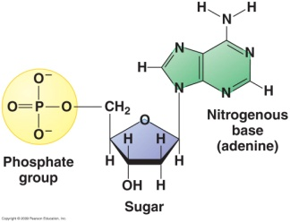 | Monosaccharide | Saturated and Unsaturated | Cellulose
Fatty Acids | 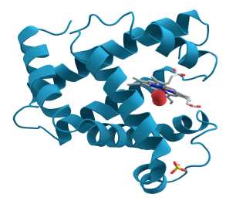 | Cell Membrane | Starch
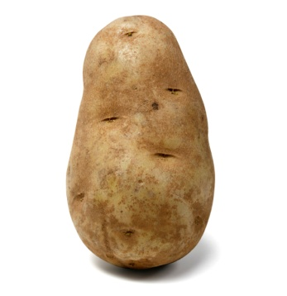 | 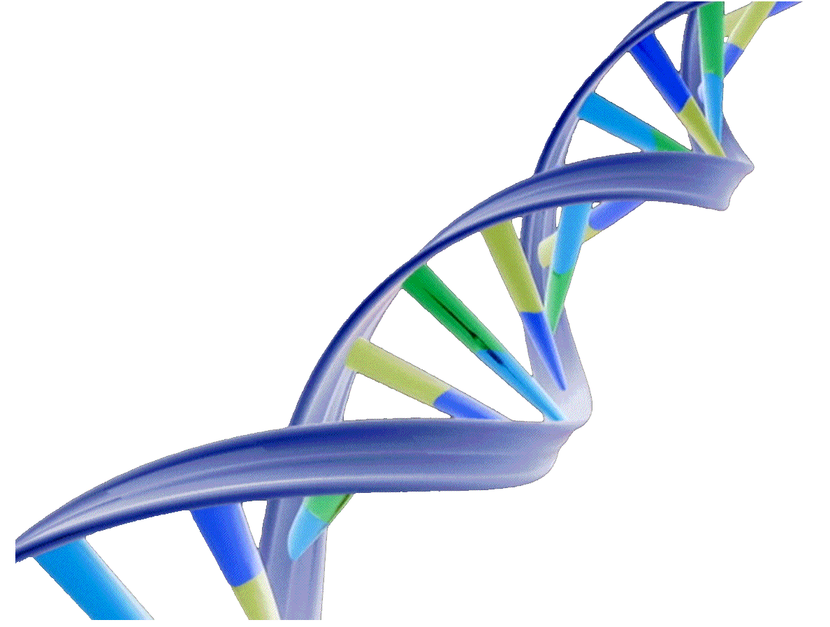 | 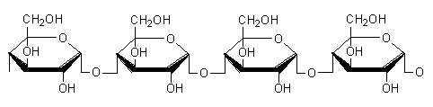 | Long Term Energy Storage for Cells
Double Helix | Enzymes and Hormones | Quick  Energy for Cells | 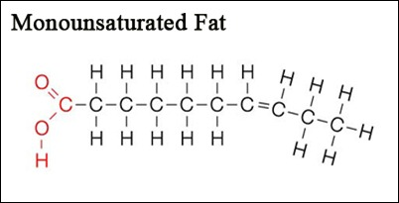
Amino Acids | 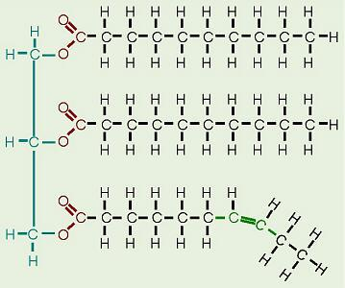 | A, T, G, C, and U | 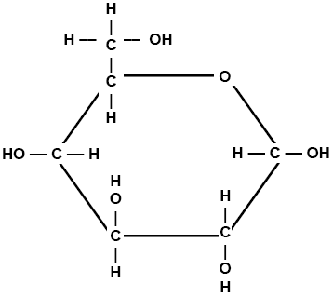
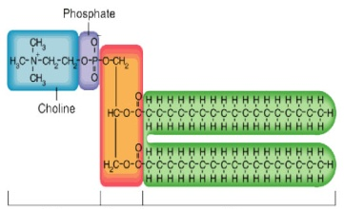 | Waxes, Steroids and Cholesterol | Peptide Bond | 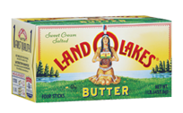
Polysaccharide | Builds  Animal  Tissues | 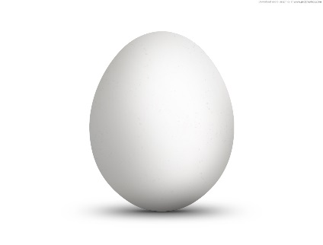 | 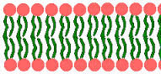
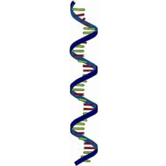 | Glycogen | Carbon and Hydrogen Chains with very Little Oxygen | 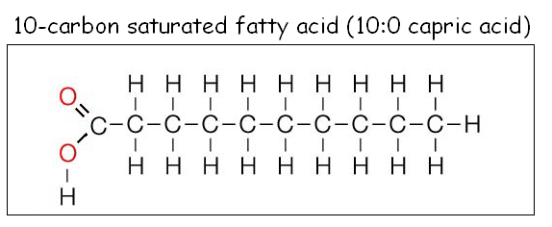
DNA and RNA | 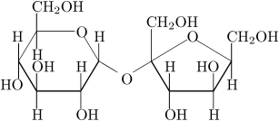 | C H O  1:2:1 | 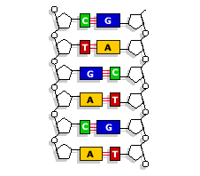
Polypeptide Chain | Nucleotide | 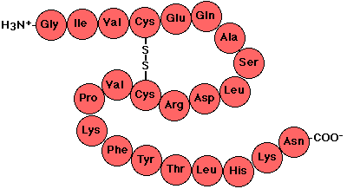 | Glucose
Glycerol Backbone | 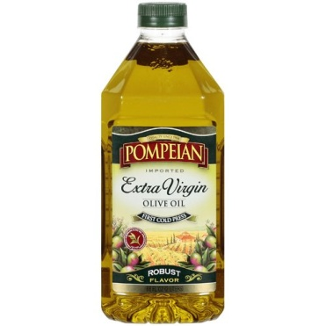 | Disaccharide | 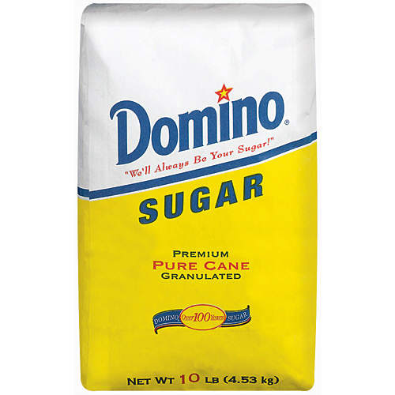
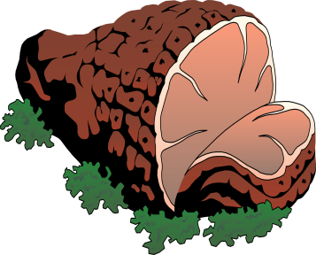 | Triglyceride | 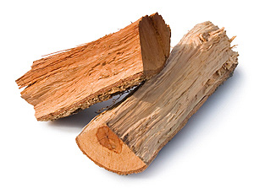 | Cell Blueprint
Using teacher notes or your device, answer the following questions about the molecules of life.
- What is the monomer for carbohydrates? _________________________________________________________
- List the four types of carbohydrates then, in detail, describe the function of each one, how they are made, and where they can be found.
  - ________________________ : ____________________________________________________________________________________________________________________________________________________________________________________________________________________________________________________________________________________________________________________________________________________
  - ________________________ : ____________________________________________________________________________________________________________________________________________________________________________________________________________________________________________________________________________________________________________________________________________________
  - ________________________ : ____________________________________________________________________________________________________________________________________________________________________________________________________________________________________________________________________________________________________________________________________________________
  - ________________________ : ____________________________________________________________________________________________________________________________________________________________________________________________________________________________________________________________________________________________________________________________________________________
- What is the monomer that makes the polymer called protein? _______________________________________
- Proteins are diverse. Please describe the following proteins and describe what they do.
  - Insulin : ____________________________________________________________________________________________________________________________________________________________________________________________________________________________________________________________________________________________________________________________________________________
  - Enzymes : ____________________________________________________________________________________________________________________________________________________________________________________________________________________________________________________________________________________________________________________________________________________
  - Hemoglobin : ____________________________________________________________________________________________________________________________________________________________________________________________________________________________________________________________________________________________________________________________________________________
- List and describe at least ten other functions of proteins within organisms.
  - _____________________________________________________________________________________
  - _____________________________________________________________________________________
  - _____________________________________________________________________________________
  - _____________________________________________________________________________________
  - _____________________________________________________________________________________
  - _____________________________________________________________________________________
  - _____________________________________________________________________________________
  - _____________________________________________________________________________________
  - _____________________________________________________________________________________
  - _____________________________________________________________________________________
- What are the two molecules that are the monomers for lipids? ______________________________________
- How are phospholipids different than triglycerides? Why are phospholipids important to organisms? ____________________________________________________________________________________________________________________________________________________________________________________________________________________________________________________________________________________________________________________________________________________________________________
- What is a steroid? How do they affect the function of an organism? ____________________________________________________________________________________________________________________________________________________________________________________________________________________________________________________________________________________________________________________________________________________________________________
- What is the monomer that makes the polymers DNA and RNA? ______________________________________
- Compare and contrast the structure of DNA and RNA. Some characteristics should include the different nitrogen bases of each and how they form long strands. ____________________________________________________________________________________________________________________________________________________________________________________________________________________________________________________________________________________________________________________________________________________________________________
- Compare and contrast the structure of DNA of a bacterium and the DNA of a human. Compare the kinds of bases in each, and the structure of the DNA of each. ____________________________________________________________________________________________________________________________________________________________________________________________________________________________________________________________________________________________________________________________________________________________________________

