Heroes of Life Name ____________________________________________
Date _____________________ Period _______________
 | Characteristic of Life | In the spaces below, describe each characteristic. | Give three different examples of each
H | Homeostasis/  Stimulus &  response | ___________________________________________________________________ ___________________________________________________________________ | _________________________________ _________________________________
E | Energy acquisition use | ___________________________________________________________________ ___________________________________________________________________ | _________________________________ _________________________________
R | Reproduction- sexual and asexual | ___________________________________________________________________ ___________________________________________________________________ | _________________________________ _________________________________
O | Organization- single and multi-celled | ___________________________________________________________________ ___________________________________________________________________ | _________________________________ _________________________________
E | Evolution and adaptation | ___________________________________________________________________ ___________________________________________________________________ | _________________________________ _________________________________
s | System growth and development | ___________________________________________________________________ ___________________________________________________________________ | _________________________________ _________________________________
of | Cells | ___________________________________________________________________ ___________________________________________________________________ | _________________________________ _________________________________

Identify the feature(s) of life that is/are illustrated by each of the following statements.
- _______________________ “That boy shot up five inches in only one year.”
- _______________________ “Our cat had a litter of kittens yesterday.”
- _______________________ “My dog has become much less clumsy now that he is a year old.”
- _______________________ “Eat a good breakfast and you will be able to run longer.”
- _______________________ “When that car pulled in the driveway, my cat ran to hide under the porch.”
- _______________________ “That owl’s night vision allows it to see the movement of mice on even the darkest night.”
- _______________________ “Single-celled organisms live in the pond behind school.”
- _______________________ Your body normally maintains a temperature of 98.6^{O}F.
- _______________________ A giraffe uses its long neck to eat from the high branches of a tree.
- _______________________ is another name for “living thing.”
Put these in order from simplest to most complex. The first and last have been done for you.
- ___Atom/Molecule___________________
- _________________________________
- _________________________________
- _________________________________
- _________________________________
- _________________________________
- _________________________________
- _________________________________
- _________________________________
- ___Biome__________________________
_____1. Atom/Molecule
_____2. Organ
_____3. Population
_____4. Biome
_____5. Cell
_____6. Organelle
_____7. Community
_____8. Ecosystem
_____9. Tissue
_____10. Organism

Match each level to its meaning.
A. All living & nonliving things on earth
B. Smallest level at which life exists
C. a group of one kind of organism living in an area
D. group of similar cells working together
E. Several populations of organisms living together
F. a living thing that may be unicellular or multicellular
G. a group of similar tissues working together like the heart or lungs
H. all the living and nonliving things living in a similar environment such as a desert
I. parts of a cell such as the nucleus
J. smallest part of an element or compound
_____1. Atom/Molecule
_____2. Organ
_____3. Population
_____4. Biome
_____5. Cell
_____6. Organelle
_____7. Community
_____8. Ecosystem
_____9. Tissue
_____10. Organism

Essay Questions
- What is the simplest level at which life may exist? Describe an example. ______________________________________________________________________________________________________________________________________________________________________________________________________
- How are cells different? Include single celled and multi-celled organisms in your explanation. ______________________________________________________________________________________________________________________________________________________________________________________________________
- What is meant by extinction? ______________________________________________________________________________________________________________________________________________________________________________________________________
- Must every member of a species be able to reproduce in order for the species to survive? Explain. ______________________________________________________________________________________________________________________________________________________________________________________________________
- Compare and contrast sexual and asexual reproduction. ______________________________________________________________________________________________________________________________________________________________________________________________________
- What is the difference between growth and development? ______________________________________________________________________________________________________________________________________________________________________________________________________
- Do unicellular organisms grow? Do they develop? ______________________________________________________________________________________________________________________________________________________________________________________________________
- Do multicellular organisms grow? Do they develop? ______________________________________________________________________________________________________________________________________________________________________________________________________
- Why is energy important to a living organism? ______________________________________________________________________________________________________________________________________________________________________________________________________
- What is the difference between an autotroph and a heterotroph? ______________________________________________________________________________________________________________________________________________________________________________________________________
- What is homeostasis? How does stimulus/response support homeostasis? ______________________________________________________________________________________________________________________________________________________________________________________________________
- Give two examples of external stimuli and two examples of internal stimuli. ______________________________________________________________________________________________________________________________________________________________________________________________________
Short Answer
- Examine these 2 organisms. Which one is unicellular and which is multicellular? (label each)
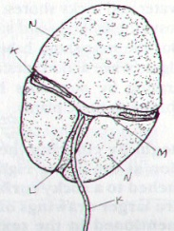
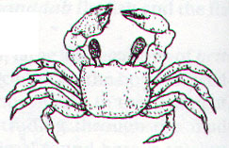

POND ORGANISM CRAB
(Under a microscope)
_______________ _______________

- Identify which graphic BEST shows growth and which BEST shows development.

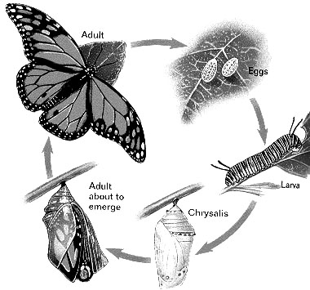
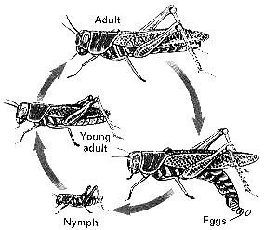

_________________________ ________________________
Students use devices. Let the students work in groups. Let them assign research to students within the group. This is a jigsaw activity. Give the individuals time to research then ask them to come together and share and discuss the information. Continue until the students complete the assignment or take it home for homework.

