Biology Honors

Benchmark #1 – Study Guide Questions (Answer Key)

1. List the 4 macromolecules (organic molecule) important to life.

a) Proteins

b) Carbohydrates

c) Lipids

d) Nucleic Acids

1. Which organic molecule contains a glycerol backbone and fatty acids? Lipids
2. DNA is categorized as which macromolecule? Nucleic Acid
3. Based on the following diagram, which cell will use energy to move the particles? How do you know?

Cell A, because energy will be used to go against the

concentration gradient.

1. Identify **each** as passive or active transport:
2. Facilitated diffusion Passive
3. Exocytosis Active
4. Osmosis Passive
5. Endocytosis Active
6. Complete the following Venn diagram

Active Transport

Passive Transport

Movement along the concentration gradient Moves against the concentration gradient

No energy Uses Energy (ATP)

Diffusion Endocytosis

Facilitated diffusion Transport of substances Exocytosis

Osmosis Use of protein Low to High

High to Low

1. Based on the following diagram, which of the following is considered a prokaryote? Which are considered a Eukaryote?

[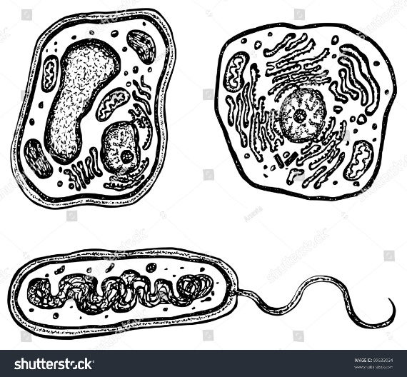](https://www.google.com/url?sa=i&rct=j&q=&esrc=s&source=images&cd=&cad=rja&uact=8&ved=2ahUKEwj0oZqMrtfdAhUGq1MKHbKKBZAQjRx6BAgBEAU&url=https://www.shutterstock.com/image-vector/plant-animal-bacteria-cells-organelles-each-69633034&psig=AOvVaw1eS8PKjRjf7uHe2654KQLL&ust=1538006290922423)

Prokaryote

Eukaryote

Eukaryote

C

B

A

1. Which organelle converts stored energy into useable energy with the presence of oxygen?

Mitochondria

1. Which organelles do plants have that animals DO NOT? Chloroplasts, Cell Wall, Large Vacuole,
2. The cell membrane is made up of which macromolecule? Lipids (phospholipid bilayer)
3. What process takes place in the following organelle? Cellular Respiration

[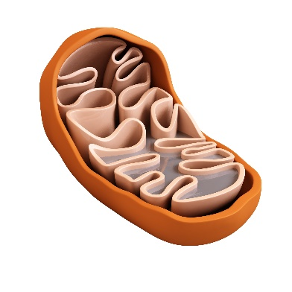](https://www.google.com/url?sa=i&rct=j&q=&esrc=s&source=images&cd=&cad=rja&uact=8&ved=2ahUKEwinht_0r9fdAhWC71MKHTbFDKkQjRx6BAgBEAU&url=https://www.parishealingarts.com/migraines-nutrients-mitochondria-methylation/&psig=AOvVaw3AMozTpfs-U6-ZGS5CntP8&ust=1538006782299114)

1. Which parts of the cell synthesizes proteins? (Makes proteins) Ribosomes found in the Endoplasmic Reticulum

For questions 13-15, use the following diagram:

[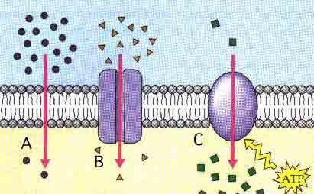](https://www.google.com/url?sa=i&rct=j&q=&esrc=s&source=images&cd=&cad=rja&uact=8&ved=2ahUKEwi_0ZbUs9fdAhUNuVMKHcJmCRwQjRx6BAgBEAU&url=http://science.halleyhosting.com/sci/soph/diffusion/rev/diff/r6.htm&psig=AOvVaw11M3DZbxZRucuDv5shP244&ust=1538007780828146)

1. Which of the following is an example of active transport? C
2. Which shows simple diffusion? A
3. What type of cell transport is used in B? Facilitated Diffusion
4. The following diagram illustrates three beakers in different percentages of salt solution. Label each as Hypertonic, Hypotonic or Isotonic.

[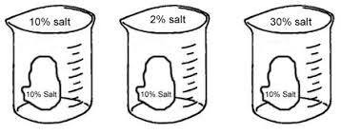](https://www.google.com/url?sa=i&rct=j&q=&esrc=s&source=images&cd=&cad=rja&uact=8&ved=2ahUKEwjyrO_WtNfdAhWFtlMKHZL_BVkQjRx6BAgBEAU&url=https://www.biologycorner.com/worksheets/diffusion_osmosis_review_key.html&psig=AOvVaw35doaFuvEh9Jvgm4vjdVez&ust=1538008041643216)

C

B

A

Isotonic Hypertonic Hypotonic

1. What reaction is occurring in the following diagram? How do you know? Photosynthesis, because it is in the presence of light energy, water, plant and a gas is formed.

[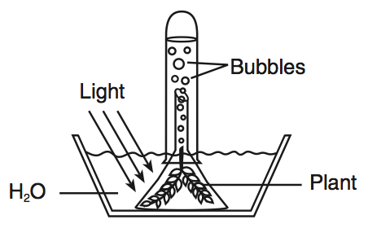](https://www.google.com/url?sa=i&rct=j&q=&esrc=s&source=images&cd=&cad=rja&uact=8&ved=2ahUKEwj6hYCptdfdAhVO2FMKHaygAXMQjRx6BAgBEAU&url=https://www.proprofs.com/quiz-school/story.php?title%3Dle-hw4111b&psig=AOvVaw3SjUi1od6b1ZHWH3a5OFQm&ust=1538008240029791)

1. Based on your answer from 17, what is the chemical equation for this reaction?

Light Energy +6CO2 + 6H2O 🡪 C6H12O6 + 6O2

1. A scientist designs an experiment to see how changes in the amount of sunlight affect the growth of grass. A sample of grass is exposed to the same amount of sunlight each day, and each day the height of the grass is measured. Other samples of grass receive different amounts of sunlight. The grass, soil, amount of water, soil temperature, and air temperature are identical for all samples.

a. What is the independent variable? Amount of sunlight

b. What is the dependent variable? Height of grass

c. What are the constant variables? Grass, soil, amt water, soil temp, air temp

1. How are cellular respiration and photosynthesis connected? Write the equations for each and explain how they are linked.

Photosynthesis: Light Energy +6CO2 + 6H2O 🡪 C6H12O6 + 6O2

Cellular Respiration: C6H12O6 + 6O2 🡪 6CO2 + 6H2O + Energy

Photosynthesis makes the glucose that is used in cellular respiration to make ATP. The glucose is then turned back into carbon dioxide, which is used in photosynthesis. While water is broken down to form oxygen during photosynthesis, in cellular respiration oxygen is combined with hydrogen to form water