Biology Honors

Benchmark #1 – Study Guide Questions

1. List the 4 macromolecules (organic molecule) important to life.

a)

b)

c)

d)

1. Which organic molecule contains a glycerol backbone and fatty acids?
2. DNA is categorized as which macromolecule?
3. Based on the following diagram, which cell will use energy to move the particles? How do you know?



1. Identify **each** as passive or active transport:
2. Facilitated diffusion
3. Exocytosis
4. Osmosis
5. Endocytosis
6. Complete the following Venn diagram

Active Transport

Passive Transport

1. Based on the following diagram, which of the following is considered a prokaryote? Which are considered a Eukaryote?

[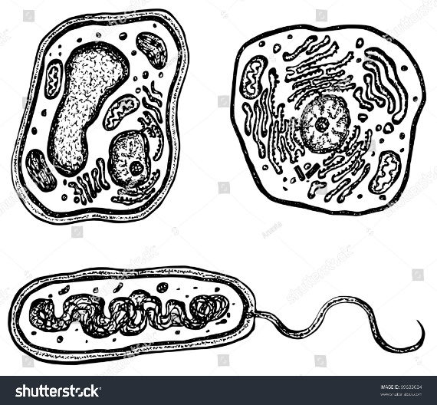](https://www.google.com/url?sa=i&rct=j&q=&esrc=s&source=images&cd=&cad=rja&uact=8&ved=2ahUKEwj0oZqMrtfdAhUGq1MKHbKKBZAQjRx6BAgBEAU&url=https://www.shutterstock.com/image-vector/plant-animal-bacteria-cells-organelles-each-69633034&psig=AOvVaw1eS8PKjRjf7uHe2654KQLL&ust=1538006290922423)

C

B

A

1. Which organelle converts stored energy into useable energy with the presence of oxygen?
2. Which organelles do plants have that animals DO NOT?
3. The cell membrane is made up of which macromolecule?
4. What process takes place in the following organelle?

[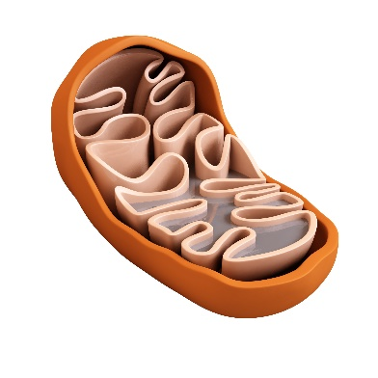](https://www.google.com/url?sa=i&rct=j&q=&esrc=s&source=images&cd=&cad=rja&uact=8&ved=2ahUKEwinht_0r9fdAhWC71MKHTbFDKkQjRx6BAgBEAU&url=https://www.parishealingarts.com/migraines-nutrients-mitochondria-methylation/&psig=AOvVaw3AMozTpfs-U6-ZGS5CntP8&ust=1538006782299114)

1. Which parts of the cell synthesizes proteins? (Makes proteins)

For questions 13-15, use the following diagram:

[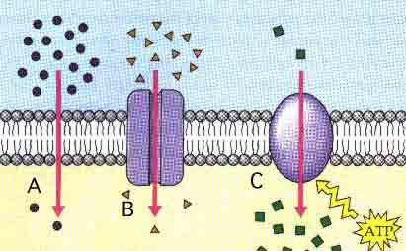](https://www.google.com/url?sa=i&rct=j&q=&esrc=s&source=images&cd=&cad=rja&uact=8&ved=2ahUKEwi_0ZbUs9fdAhUNuVMKHcJmCRwQjRx6BAgBEAU&url=http://science.halleyhosting.com/sci/soph/diffusion/rev/diff/r6.htm&psig=AOvVaw11M3DZbxZRucuDv5shP244&ust=1538007780828146)

1. Which of the following is an example of active transport?
2. Which shows simple diffusion?
3. What type of cell transport is used in B?
4. The following diagram illustrates three beakers in different percentages of salt solution. Label each as Hypertonic, Hypotonic or Isotonic.

[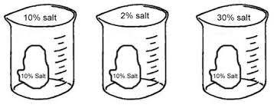](https://www.google.com/url?sa=i&rct=j&q=&esrc=s&source=images&cd=&cad=rja&uact=8&ved=2ahUKEwjyrO_WtNfdAhWFtlMKHZL_BVkQjRx6BAgBEAU&url=https://www.biologycorner.com/worksheets/diffusion_osmosis_review_key.html&psig=AOvVaw35doaFuvEh9Jvgm4vjdVez&ust=1538008041643216)

C

B

A

1. What reaction is occurring in the following diagram? How do you know?

[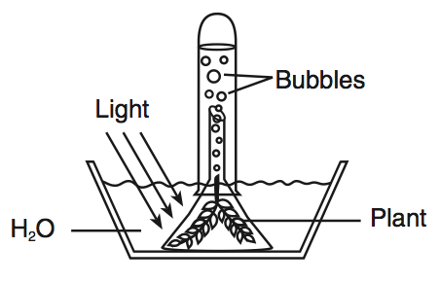](https://www.google.com/url?sa=i&rct=j&q=&esrc=s&source=images&cd=&cad=rja&uact=8&ved=2ahUKEwj6hYCptdfdAhVO2FMKHaygAXMQjRx6BAgBEAU&url=https://www.proprofs.com/quiz-school/story.php?title%3Dle-hw4111b&psig=AOvVaw3SjUi1od6b1ZHWH3a5OFQm&ust=1538008240029791)

1. Based on your answer from 17, what is the chemical equation for this reaction?
2. A scientist designs an experiment to see how changes in the amount of sunlight affect the growth of grass. A sample of grass is exposed to the same amount of sunlight each day, and each day the height of the grass is measured. Other samples of grass receive different amounts of sunlight. The grass, soil, amount of water, soil temperature, and air temperature are identical for all samples.

a. What is the independent variable?

b. What is the dependent variable?

c. What are the controlled variables

1. How are cellular respiration and photosynthesis connected? Write the equations for each and explain how they are linked.