Protein Synthesis Essential Standard 3.1.2
Name ______________________________________________________ Date ________________ Period ____________

- What is transcription? What is made during this process? ______________________________________________________________________________________________________________________________________________________________________________________
- Where does transcription take place in the cell? ___________________________________________________
- What is made using the “message” on messenger RNA (mRNA)? ______________________________________________
- What is the job of the mRNA? ___________________________________________________________________________________________
- What is the job of the rRNA? ___________________________________________________________________________________________
- What is the job of the tRNA? ___________________________________________________________________________________________
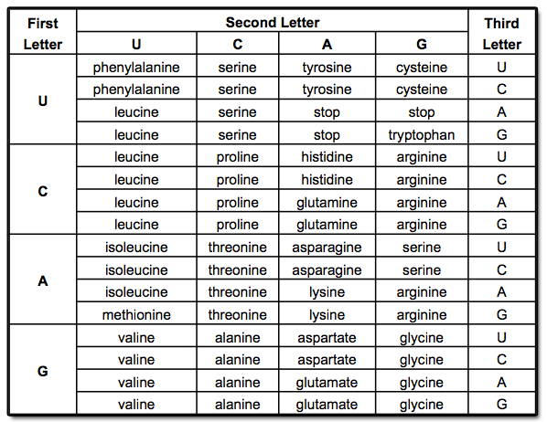
- Determine the amino acid sequence from the following strand of mRNA using the codon chart above.
AUGUGACCUGACUUAUAG
___________________________________________________________________________________________
- What is the “start” codon? ____________________________________________________________________
- What is “translation” in protein synthesis? ___________________________________________________________________________________________
- Where does translation occur in the cell? _________________________________________________________
- What bond is used to connect the amino acids? ____________________________________________________
- What is another name for an amino acid chain? ____________________________________________________
- What is another name for polypeptide chain? ______________________________________________________
- DNA determines what proteins are being made. What determines when proteins are being made? ______________________________________________________________________________________________________________________________________________________________________________________
- Describe the following proteins:
  - Hormones __________________________________________________________________________________________________________________________________________________________________________
  - Enzymes __________________________________________________________________________________________________________________________________________________________________________
  - Cyclins __________________________________________________________________________________________________________________________________________________________________________
  - Muscle protein __________________________________________________________________________________________________________________________________________________________________________
  - Mucus __________________________________________________________________________________________________________________________________________________________________________
  - Cartilage __________________________________________________________________________________________________________________________________________________________________________
  - Keratin __________________________________________________________________________________________________________________________________________________________________________
  - Insulin __________________________________________________________________________________________________________________________________________________________________________
- Describe how a gene leads to the expression of a single trait of an organism. Include transcription, translation, switches, genotype and phenotype. _______________________________________________________________________________________________________________________________________________________________________________________________________________________________________________________________________________________________________________________________________________________________________________________________________________________________________________________________________

