DNA Structure Essential Standard 3.1.1 (Part I)
Name ______________________________________________________ Date ________________ Period ____________

- Label the sugar, phosphate and nitrogen base of this nucleotide.
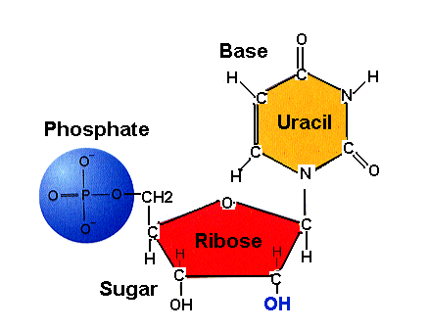

- How many nitrogen bases are there? _________________
- Name all of the nitrogen bases. ___________________________________________________________________________________________
- Which bases make up a DNA molecule? __________________________
- Which bases make up an RNA molecule? __________________________
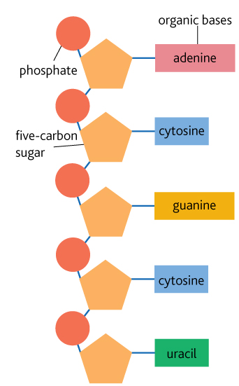
- Is the strand of nucleic acid above DNA or RNA? Circle one nucleotide. How do you know? Give two reasons for your identification. ___________________________________________________________________________________________
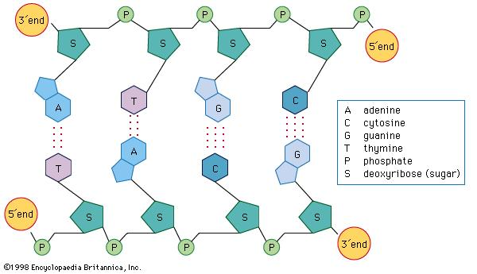

- Is the strand of nucleic acid above DNA or RNA? Circle one nucleotide. How do you know? Give two reasons for your identification. ___________________________________________________________________________________________
- In the DNA molecule above, what type of bond holds the nitrogen bases of the molecule together? ___________________________________________________________________________________________
- Why is DNA said to be a “double helix?” Give details. ______________________________________________________________________________________________________________________________________________________________________________________
- What two parts of the nucleotides make the sides of a DNA molecule? ___________________________________________________________________________________________
- What part of a nucleotide make the “rungs” of the twisted ladder structure? ____________________________
- In two DNA strands, when matching nitrogen bases, A always matches with ___________________ and C always matches with ____________________.
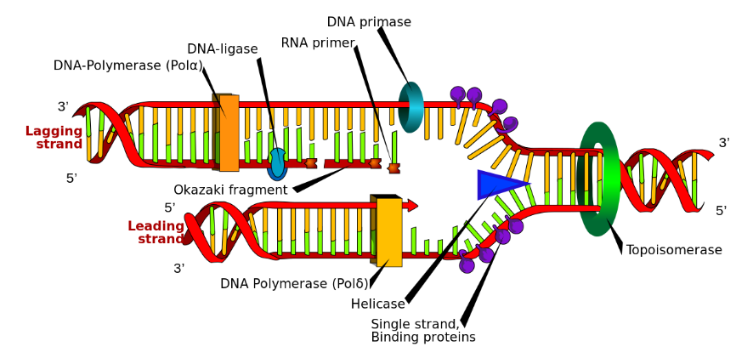
- What process does this diagram represent? ___________________________________________________
- During what part of the cell cycle does this process occur? __________________________________________
- Why is this process important for new cells made during mitosis? ______________________________________________________________________________________________________________________________________________________________________________________
- When mRNA is being made, mRNA matches to DNA so that A of the DNA matches to a/an __________________ of the RNA and a C always matches to a/an _____________________.
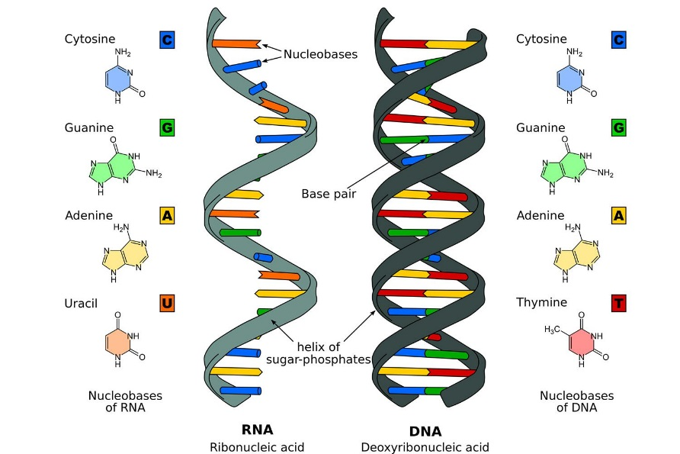
- Circle the differences between the DNA and RNA strands pictured above. Describe the differences. _________________________________________________________________________________________________________________________________________________________________________________________________________________________________________________________________________________

