DNA Function Essential Standard 3.1.1 (Part II)
Name ______________________________________________________ Date ________________ Period ____________
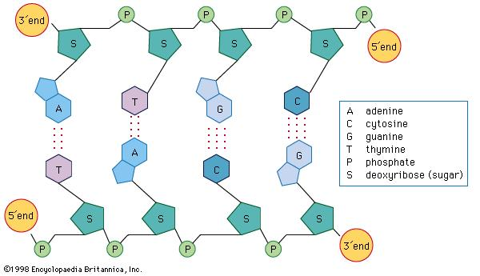
Backbone #2
Backbone #1

- If the gene for a protein is on backbone #1, what is the partial code for the gene shown in the diagram above? _______________________________________________
- What is the matching code on backbone #2? _______________________________________________
- What messenger RNA (mRNA) would be “transcribed” from the partial gene on backbone #1? _______________________________________________
- Can the environment turn genes off and on? ______________________ Give three examples. (Example: why would a human body stop producing a protein called insulin even though it is necessary for normal function?)
  - _____________________________________________________________________________________
  - _____________________________________________________________________________________
  - _____________________________________________________________________________________
- Compare the DNA of one of your skin cells to the DNA of one of your brain cells. ______________________________________________________________________________________________________________________________________________________________________________________
- If all cells of an organism have the same DNA, why do different cells look different and act differently? ______________________________________________________________________________________________________________________________________________________________________________________
- If all cells of an organism have the same DNA, why do different cells produce different proteins in different amounts? ______________________________________________________________________________________________________________________________________________________________________________________
- Name three advantages of multiple cellular organisms making new cells (mitosis).
  - _____________________________________________________________________________________
  - _____________________________________________________________________________________
  - _____________________________________________________________________________________
- Why is it called a disease when cells continue to divide uncontrollably?
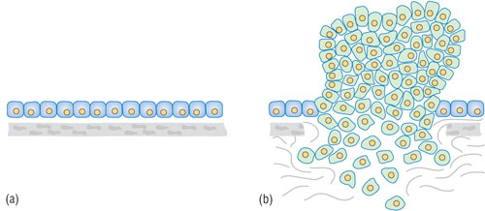
______________________________________________________________________________________________________________________________________________________________________________________
- Why is it a problem if cells in a multicellular organism produces too much of a protein? Give an example. ______________________________________________________________________________________________________________________________________________________________________________________
- Why is it a problem if cells in a multicellular organism produces too little of a protein? Give an example. ______________________________________________________________________________________________________________________________________________________________________________________

