Prokaryote or Eukaryote? Essential Standard 1.1.2
Name ___________________________________________________________ Date _______________ Period ________
Some of these ask you to identify pictures and others ask you to identify terms.
- Prokaryote or Eukaryote? How do you know? Be specific. ______________________________________________________________________________________________________________________________________________________________________________________
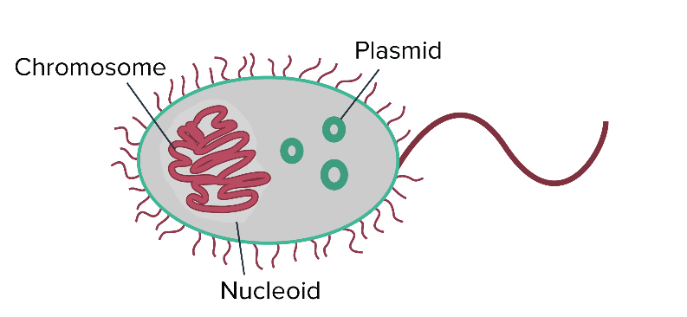
- Fungus: Prokaryote or Eukaryote? How do you know? Be specific. ______________________________________________________________________________________________________________________________________________________________________________________

- Archaebacteria: Prokaryote or Eukaryote? How do you know? Be specific. ______________________________________________________________________________________________________________________________________________________________________________________
- Prokaryote or Eukaryote? How do you know? Be specific. ______________________________________________________________________________________________________________________________________________________________________________________
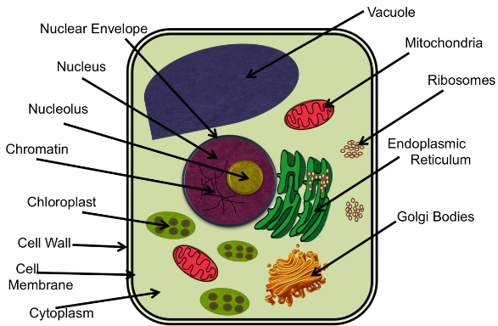
- Raccoon: Prokaryote or Eukaryote? How do you know? Be specific. ______________________________________________________________________________________________________________________________________________________________________________________
- Prokaryote or Eukaryote? How do you know? Be specific. ______________________________________________________________________________________________________________________________________________________________________________________
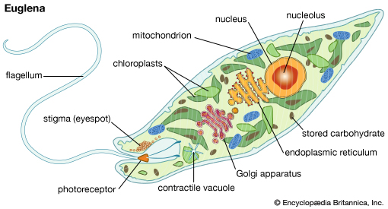

- Prokaryote or Eukaryote? How do you know? Be specific. ______________________________________________________________________________________________________________________________________________________________________________________
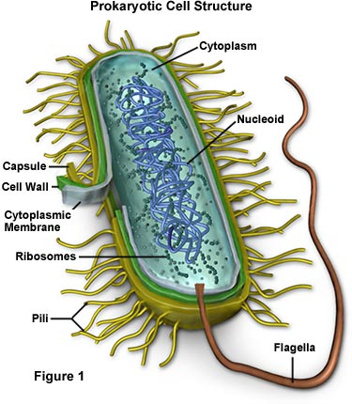
- Prokaryote or Eukaryote? How do you know? Be specific. ______________________________________________________________________________________________________________________________________________________________________________________
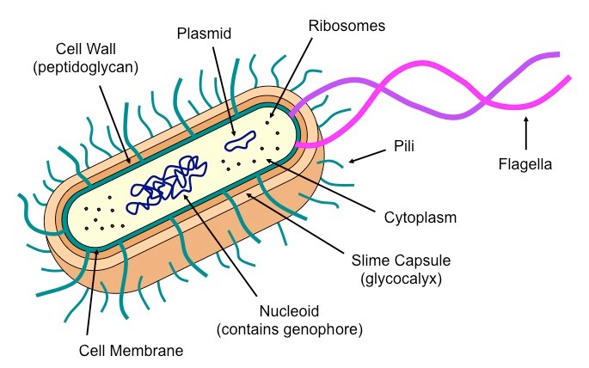
- Prokaryote or Eukaryote? How do you know? Be specific. ______________________________________________________________________________________________________________________________________________________________________________________
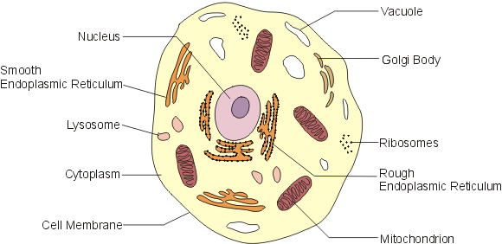
- Eubacteria: Prokaryote or Eukaryote? How do you know? Be specific. ______________________________________________________________________________________________________________________________________________________________________________________
- Protist: Prokaryote or Eukaryote? How do you know? Be specific. ______________________________________________________________________________________________________________________________________________________________________________________

- Prokaryote or Eukaryote? How do you know? Be specific. ______________________________________________________________________________________________________________________________________________________________________________________
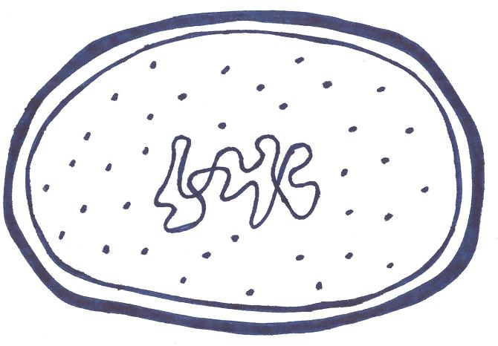
- White Pine Tree: Prokaryote or Eukaryote? How do you know? Be specific. ______________________________________________________________________________________________________________________________________________________________________________________
- Human: Prokaryote or Eukaryote? How do you know? Be specific. ______________________________________________________________________________________________________________________________________________________________________________________

