Cell Review Essential Standard 1.1.1
Name _________________________________________________________ Date _______________ Period __________
Label the cells using the following terms:
Smooth endoplasmic reticulum Nucleus Nucleolus
Rough endoplasmic reticulum Cell membrane Contractile vacuole
Chromatin Ribosomes Golgi body
Mitochondria Vacuole Lysosome
Cytoplasm Cell Wall Chloroplast
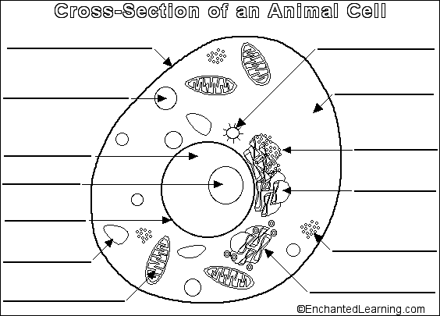

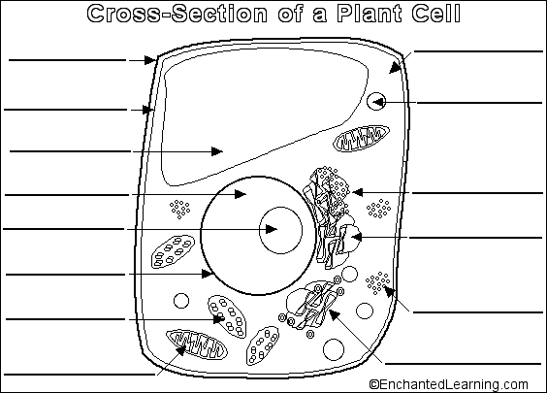

Describe the function of each of the organelles. Explain why they are important to the cells.
- Smooth endoplasmic reticulum ______________________________________________________________________________________________________________________________________________________________________________________
- Nucleus ______________________________________________________________________________________________________________________________________________________________________________________
- Nucleolus ______________________________________________________________________________________________________________________________________________________________________________________
- Rough endoplasmic reticulum ______________________________________________________________________________________________________________________________________________________________________________________
- Cell membrane ______________________________________________________________________________________________________________________________________________________________________________________
- Contractile vacuole ______________________________________________________________________________________________________________________________________________________________________________________
- Chromatin ______________________________________________________________________________________________________________________________________________________________________________________
- Ribosomes ______________________________________________________________________________________________________________________________________________________________________________________
- Golgi body ______________________________________________________________________________________________________________________________________________________________________________________
- Mitochondria ______________________________________________________________________________________________________________________________________________________________________________________
- Vacuole ______________________________________________________________________________________________________________________________________________________________________________________
- Lysosome ______________________________________________________________________________________________________________________________________________________________________________________
- Cytoplasm ______________________________________________________________________________________________________________________________________________________________________________________

